Fitting time series models
A R I M A M O D E L S I N P Y T H O N

James Fulton
Climate informatics researcher

Creating a model
statsmodels.tsa.arima.model
ARIMA
# This is an ARMA(p,q) model
model = ARIMA(timeseries, order=(p,0,q))

Creating AR and MA models
ar_model = ARIMA(timeseries, order=(p,0,0))
ma_model = ARIMA(timeseries, order=(0,0,q))

Fitting the model and fit summary
model = ARIMA(timeseries, order=(2,0,1)) results = model.fit()
print(results.summary())

SARIMAX Results
==============================================================================
==============================================================================
coef std err z P>|z| [0.025 0.975]

Dep. Variable: |  | y | No. | Observations: | 1000
Model: |  | ARMA(2, 1) | Log | Likelihood | 148.580
Date: | Thu, | 25 Apr 2022 | AIC |  | -287.159
Time: |  | 22:57:00 | BIC |  | -262.621
Sample: |  | 0 | HQIC |  | -277.833
Covariance Type: |  | opg

const | -0.0017 | 0.012 | -0.147 | 0.883 | -0.025 | 0.021
ar.L1.y | 0.5253 | 0.054 | 9.807 | 0.000 | 0.420 | 0.630
ar.L2.y | -0.2909 | 0.042 | -6.850 | 0.000 | -0.374 | -0.208
ma.L1.y | 0.3679 | 0.052 | 7.100 | 0.000 | 0.266 | 0.469

SARIMAX Results
==============================================================================
Dep. Variable: y No. Observations: 1000
Model: ARMA(2, 1) Log Likelihood 148.580
Date: Thu, 25 Apr 2022 AIC -287.159

Time: | 22:57:00 | BIC | -262.621
Sample: | 0 | HQIC | -277.833
Covariance Type: opg

==============================================================================
coef
std err
z
P>|z|
[0.025
0.975]

const | -0.0017 | 0.012 | -0.147 | 0.883 | -0.025 | 0.021
ar.L1.y | 0.5253 | 0.054 | 9.807 | 0.000 | 0.420 | 0.630
ar.L2.y | -0.2909 | 0.042 | -6.850 | 0.000 | -0.374 | -0.208
ma.L1.y | 0.3679 | 0.052 | 7.100 | 0.000 | 0.266 | 0.469
sigma2 | 1.6306 | 0.339 | 6.938 | 0.000 | 0.583 | 1.943

Introduction to ARMAX models
Exogenous ARMA
Use external variables as well as time series ARMAX = ARMA + linear regression

ARMAX equation
ARMA(1,1) model :

ARMAX(1,1) model :

yt = a1yt−1

+ m1ϵt−1

+ ϵ_{t}

y_{t} = x₁z_{t}
+ a1yt−1
+ m1ϵt−1
+ ϵ_{t}

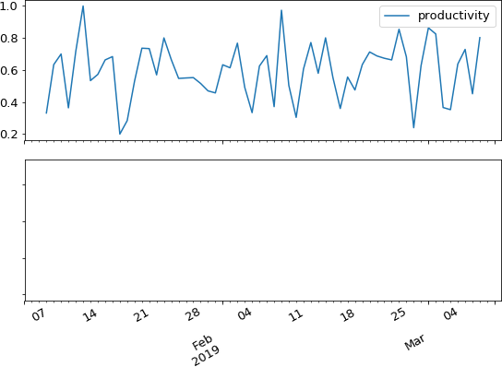

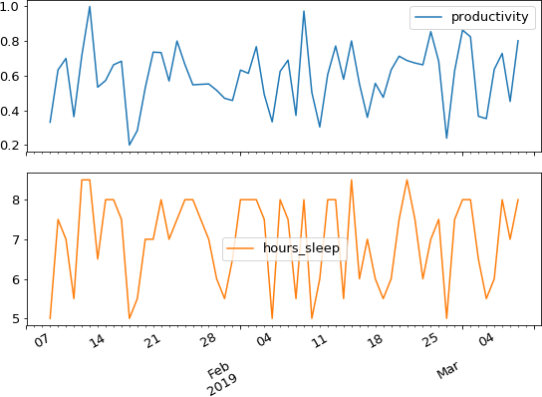

Fitting ARMAX
# Instantiate the model
model = ARIMA(df['productivity'], order=(2,0,1), exog=df['hours_sleep'])
# Fit the model
results = model.fit()

ARMAX summary
==============================================================================
coef
std err
z
P>|z|
[0.025
0.975]

const | -0.1936 | 0.092 | -2.098 | 0.041 | -0.375 | -0.013
x1 | 0.1131 | 0.013 | 8.602 | 0.000 | 0.087 | 0.139
ar.L1.y | 0.1917 | 0.252 | 0.760 | 0.450 | -0.302 | 0.686
ar.L2.y | -0.3740 | 0.121 | -3.079 | 0.003 | -0.612 | -0.136
ma.L1.y | -0.0740 | 0.259 | -0.286 | 0.776 | -0.581 | 0.433

Let's practice!
A R I M A M O D E L S I N P Y T H O N

Forecasting
A R I M A M O D E L S I N P Y T H O N

James Fulton
Climate informatics researcher

Predicting the next value
Take an AR(1) model

yt = a1yt−1
+ ϵ_{t}

Predict next value
y_{t} = 0.6 x 10 + ϵ_{t} y_{t} = 6.0 + ϵ_{t}
Uncertainty on prediction
5.0 < y_{t} < 7.0

One-step-ahead predictions
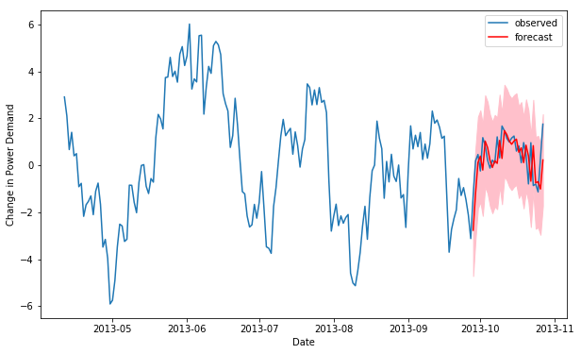

# Make predictions for last 25 values results = model.fit()
# Make in-sample prediction
forecast = results.get_prediction(start=-25)

# Make predictions for last 25 values results = model.fit()
# Make in-sample prediction
forecast = results.get_prediction(start=-25) # forecast mean
mean_forecast = forecast.predicted_mean

Predicted mean is a pandas series

2013-10-28 | 1.519368
2013-10-29 | 1.351082
2013-10-30 | 1.218016

Confidence intervals
pandas
# Get confidence intervals of forecasts confidence_intervals = forecast.conf_int()
Confidence interval method returns DataFrame

 | lower y | upper y
2013-09-28 | -4.720471 | -0.815384
2013-09-29 | -5.069875 | 0.112505
2013-09-30 | -5.232837 | 0.766300
2013-10-01 | -5.305814 | 1.282935
2013-10-02 | -5.326956 | 1.703974

plt.figure()

# Plot prediction plt.plot(dates,
mean_forecast.values, color='red', label='forecast')
# Shade uncertainty area
plt.fill_between(dates, lower_limits, upper_limits, color='pink')

plt.show()



Dynamic predictions
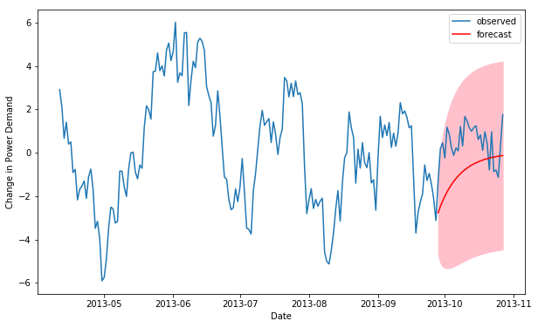

Making dynamic predictions
results = model.fit()
forecast = results.get_prediction(start=-25, dynamic=True)
# forecast mean
mean_forecast = forecast.predicted_mean
# Get confidence intervals of forecasts
confidence_intervals = forecast.conf_int()

# forecast mean
mean_forecast = forecast.predicted_mean
# Get confidence intervals of forecasts
confidence_intervals = forecast.conf_int()

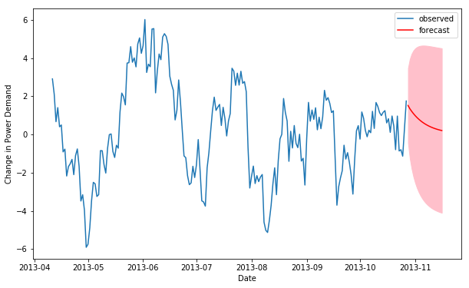

Let's practice!
A R I M A M O D E L S I N P Y T H O N

Introduction to ARIMA models
A R I M A M O D E L S I N P Y T H O N

James Fulton
Climate informatics researcher

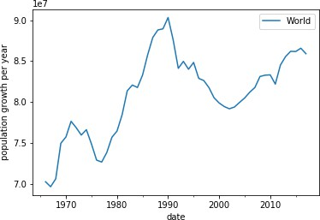

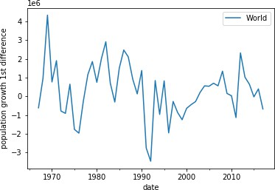

Forecast of differenced time series

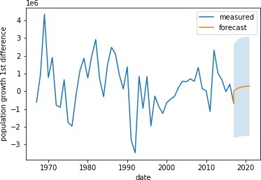

Reconstructing original time series after differencing
diff_forecast = results.get_forecast(steps=10).predicted_mean
numpy
cumsum
mean_forecast = cumsum(diff_forecast)

diff_forecast = results.get_forecast(steps=10).predicted_mean
numpy
cumsum
mean_forecast = cumsum(diff_forecast) + df.iloc[-1,0]

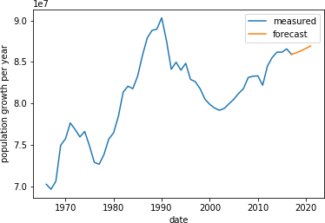

The ARIMA model

Take the difference Fit ARMA model
Integrate forecast
Can we avoid doing so much work? Yes!
ARIMA - Autoregressive Integrated Moving Average

statsmodels.tsa.arima.model
model = ARIMA(df, order=(p,d,q))
ARIMA
p - number of autoregressive lags d - order of differencing
q - number of moving average lags ARIMA(p, 0, q) = ARMA(p, q)

# Create model
model = ARIMA(df, order=(2,1,1)) # Fit model
model.fit()
# Make forecast
mean_forecast = results.get_forecast(steps=10).predicted_mean

# Make forecast
mean_forecast = results.get_forecast(steps=steps).predicted_mean



adf = adfuller(df.iloc[:,0]) print('ADF Statistic:', adf[0]) print('p-value:', adf[1])
ADF Statistic: -2.674
p-value: 0.0784
adf = adfuller(df.diff().dropna().iloc[:,0]) print('ADF Statistic:', adf[0])
print('p-value:', adf[1])
ADF Statistic: -4.978 p-value: 2.44e-05

model = ARIMA(df, order=(p,1,q))

Let's practice!
A R I M A M O D E L S I N P Y T H O N

